SCUBA-2 Block Specification
async_fifo

February 15, 2005
Table of Contents

1. Block Overview 3
1.1 Block Location and Block Interface Within System 3
1.2 Block Functionality / Features 3
1.3 Block Dataflow 3
2. Block Interfaces 4
2.1 Interface Signal Description 4
2.2 Interface Protocol and Timing 4
3. High-Level Description 5
3.1 Block Description 5
4. Files of the Block 6
4.1 Source Code 6
4.1.1 async_fifo.vhd 6
4.2 Header Code 6

Block Overview

Block Location and Block Interface Within System
This block is instantiated by the following entities, which are both located on the clock card FPGA.
- rx_fifo
- tx_fifo

Block Functionality / Features
- This block is a byte wide asynchronous FIFO.
- It includes an asynchronous clear, fifo_empty and fifo_full flags.
- The size of the FIFO can be chosen when it is instantiated by mapping the desired address size to the generic port “addr_size”. The resultant size of the fifo will be 2^{addr_size}.
- Simultaneous read and writes are permitted.

Block Dataflow

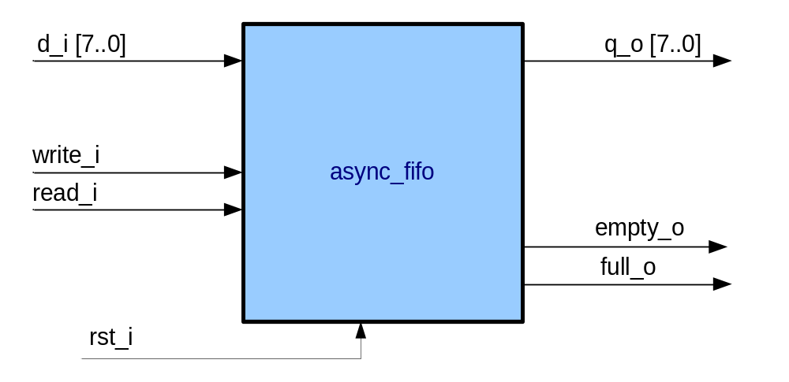

Block Interfaces

Interface Signal Description
- Interface Signals
Signal | Description | Direction
Global Signals
rst_i | Asynchronous FIFO reset | in
Control Signals
write_i | FIFO write request. When asserted high ata on d_i is written to the FIFO. | in
read_i | FIFO read request. When asserted high data from the FIFO is available to read from q_o. | in
d_i | Byte wide data input to FIFO | in
q_o | Byte wide data output from FIFO | out
full_o | FIFO full flag. When high full_o indicates that the FIFO is full and should not be written to. | out
empty_o | FIFO empty flag. When high empty_o indicates that the FIFO is empty and should not be read from. | out

Interface Protocol and Timing

High-Level Description

Block Description

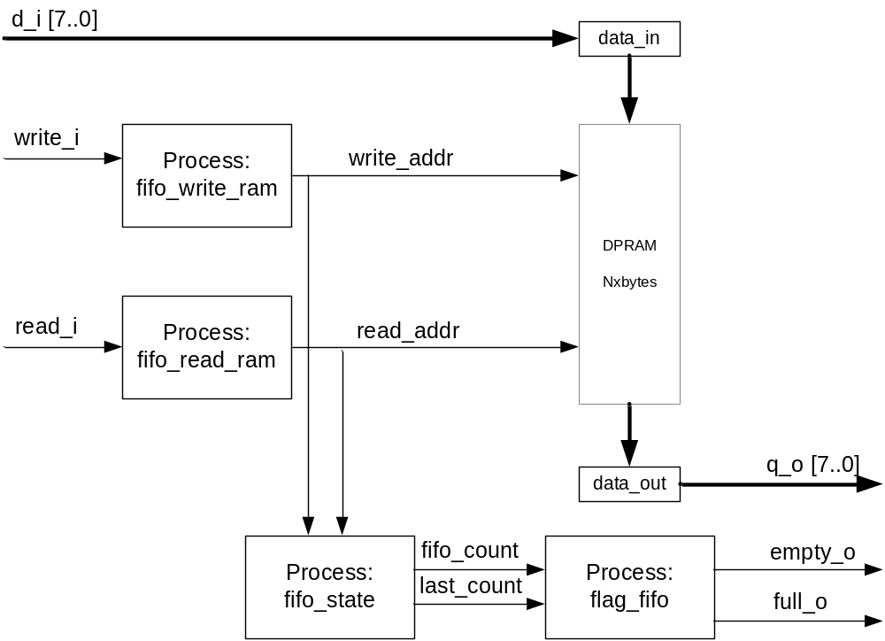

The core of async_fifo is a byte-wide Dual Port Ram (DPRAM), which acts as a circular buffer. Reading and writing to the DPRAM is controlled by the processes “fifo_read_ram”, and “fifo_write_ram” respectively. A positive going edge on the input “write_i” will initiate “fifo_write_ram” to write data on d_i [7..0] to the DPRAM at the address given by “write_addr”, it will then increment write_addr. Similarly, a positive going edge on the input “read_i” will initiate fifo_read_ram to read data from the DPRAM at the address given by read_addr, thereby making it available at the output “q_o[7..0]”. It will then increment read_addr.
The process “fifo_state” monitors the current values of read_addr, and write_addr to calculate “fifo_count” - the current number of unread bytes in the FIFO. Furthermore, when read_addr or write_addr are incremented the previous value of “fifo_count” is stored in “last_count”. This permits the last operation to be established since if “fifo_count” is one more than “last_count” then the last operation must have been a write, whereas if “fifo_count” is one less then “last_count” then the last operation must have been a read. This information is required by the process “flag_fifo” to establish when the fifo is full or empty. The DPRAM behaves as a circular buffer so “fifo_count” will equal zero (write_addr = read_addr) for both the full and empty conditions. Therefore, it is the value of last_count that determines if the fifo is full or empty. For example, if “fifo_count” equals zero and “last_count” equals one then the fifo must be empty, where if “fifo_count” equals zero and “last_count” equals N-1 (where N = the size of the fifo) then the fifo must be full.

Files of the Block

Source Code

async_fifo.vhd

Header Code

